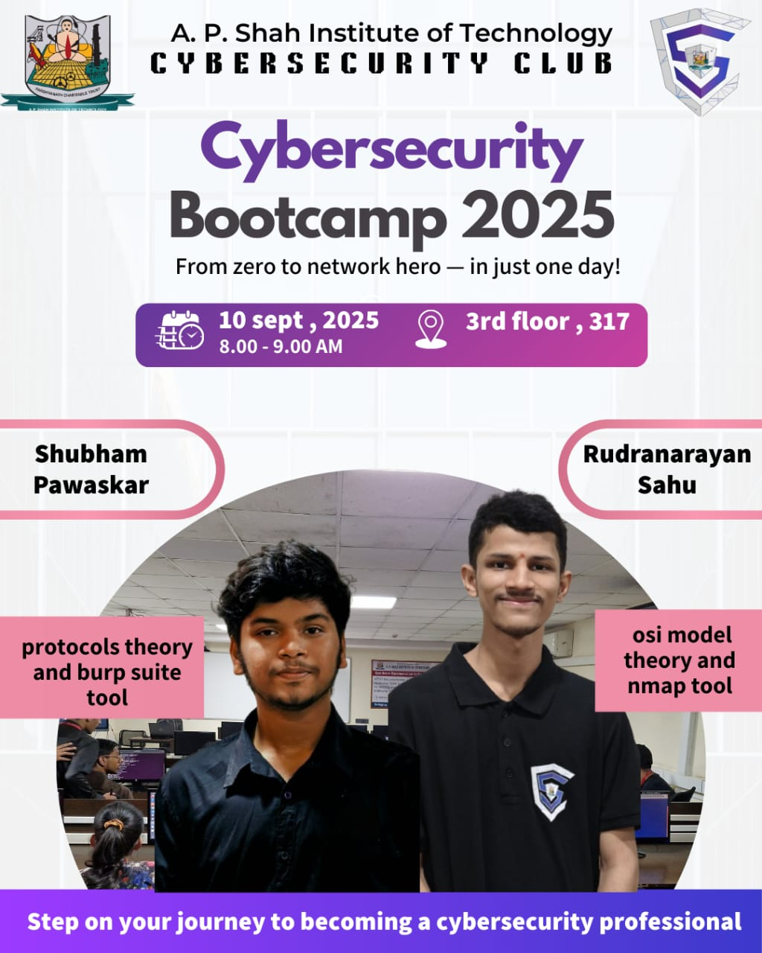
Session: Bootcamp 2025 Session 2 (Networking & Security)

Name of College: A. P. Shah Institute of Technology, Kasarvadavali, Ghodbunder Road, Thane – 400615

Date: 17/09/2025
Venue: 317
Participants:
Targeted Audience: Students Interested in Cybersecurity learning domain from IT, CS, DS, AIML Department.
Speaker:
- Shubham Pawaskar (Technical Co-head)
- Rudranarayan Sahu (Technical Co-head)

Faculty Accompanied:

Prof. Sneha Dalvi

Prof. Randeep Kaur Kahlon

Prof. Saylee Lapalikar

Prof. Manjusha Kashilkar.

Organizers:
Cybersecurity Club, A. P. Shah Institute of Technology

Aim of Event: The objective of this session was to provide students with advanced insights into computer networking and its applications in cybersecurity. The session particularly focused on the practical understanding of network protocols, network scanning, and web application security testing tools.

The session commenced with an introduction to network protocols as the backbone of digital communication. The speakers elaborated on the functionality of TCP, UDP, IP, ARP, HTTP/HTTPS, and FTP, and illustrated their relevance through everyday use cases such as web browsing, emailing, and media streaming.

The workshop then progressed to the practical demonstration of Nmap (Network Mapper), a widely recognized tool for network discovery and vulnerability assessment. Students were guided through tasks such as IP and port scanning, service version detection, operating system fingerprinting, and firewall analysis. The Nmap Scripting Engine was also introduced for vulnerability detection.

Subsequently, participants were introduced to Burp Suite, a leading tool for web application security testing. Demonstrations included intercepting and analyzing traffic, identifying security flaws, and understanding common vulnerabilities such as SQL injection and cross-site scripting (XSS). The session emphasized the importance of ethical hacking methodologies in ensuring secure application development.

The session enabled students to acquire a comprehensive understanding of the role and significance of network protocols in ensuring secure communication, while also gaining practical exposure to the use of Nmap for network auditing and vulnerability assessment. Overall, the event successfully integrated theoretical knowledge with practical application, thereby enhancing the participants’ proficiency in networking and cybersecurity, and concluded with the emphasis on continuous learning as a vital step toward becoming proficient cybersecurity professionals.

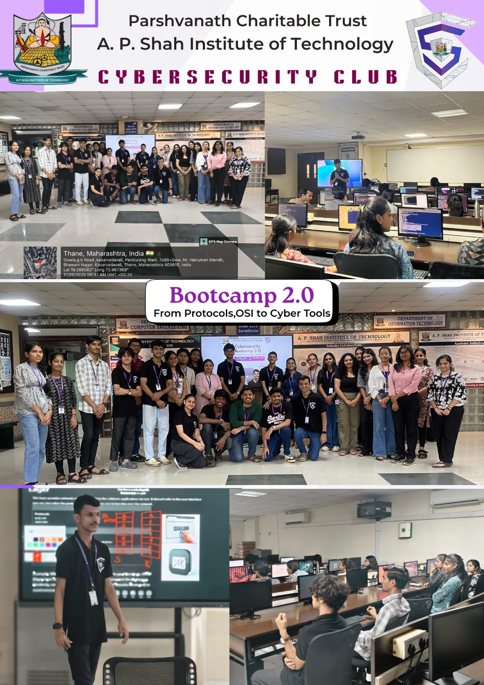

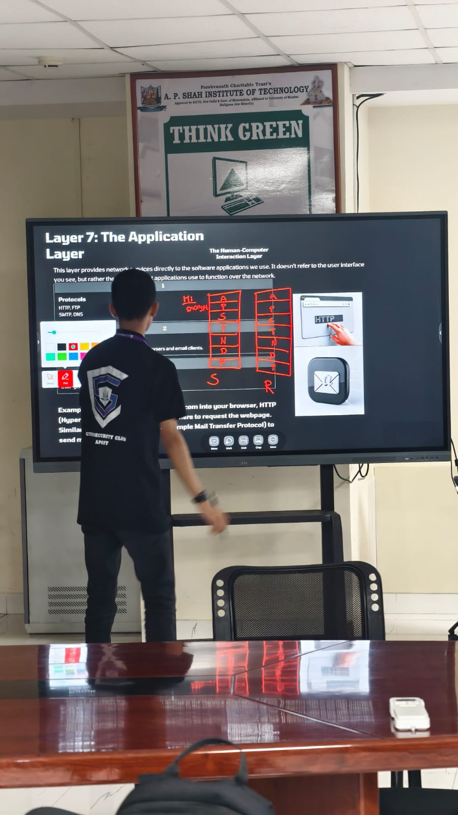

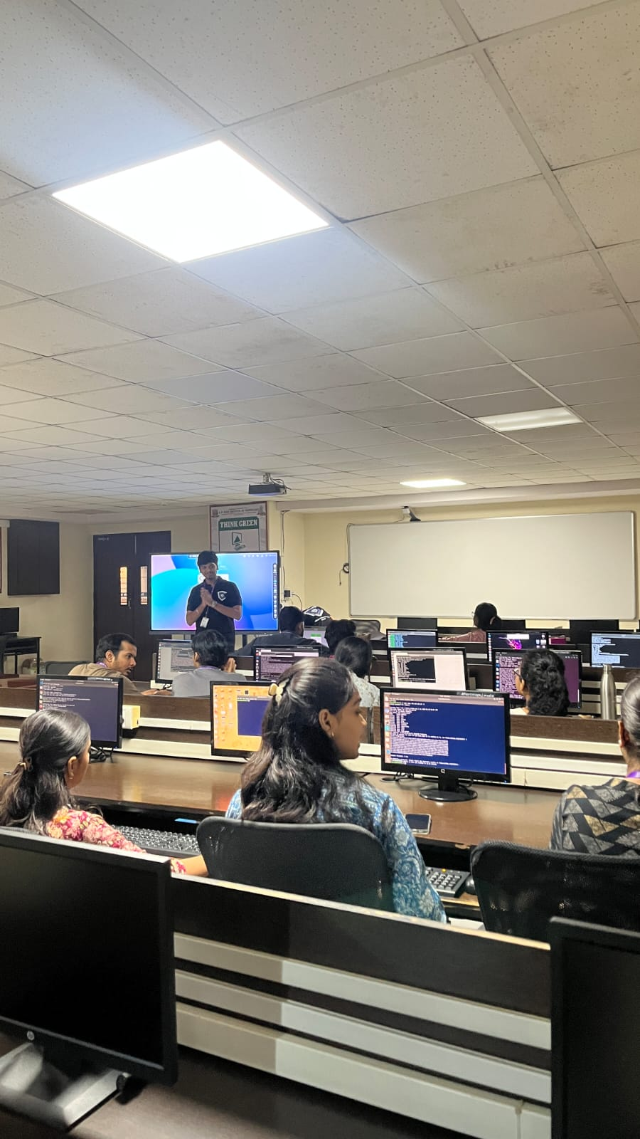

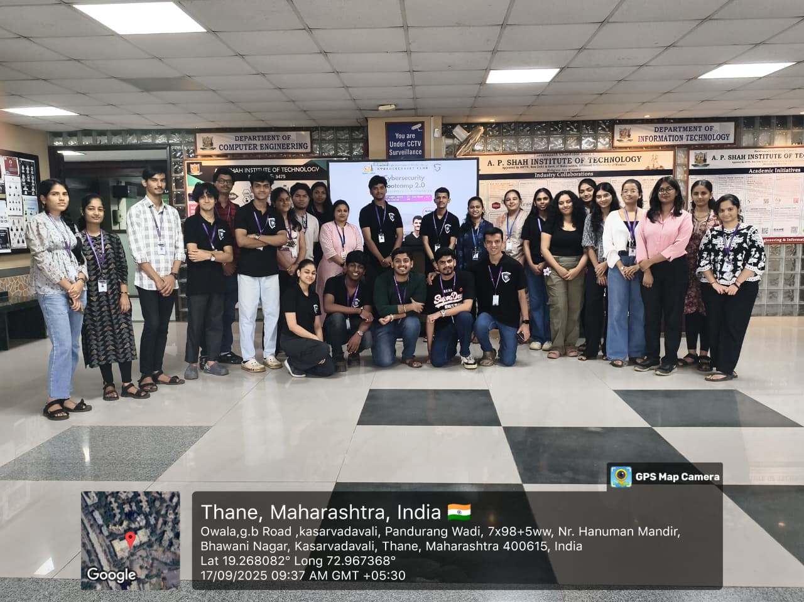

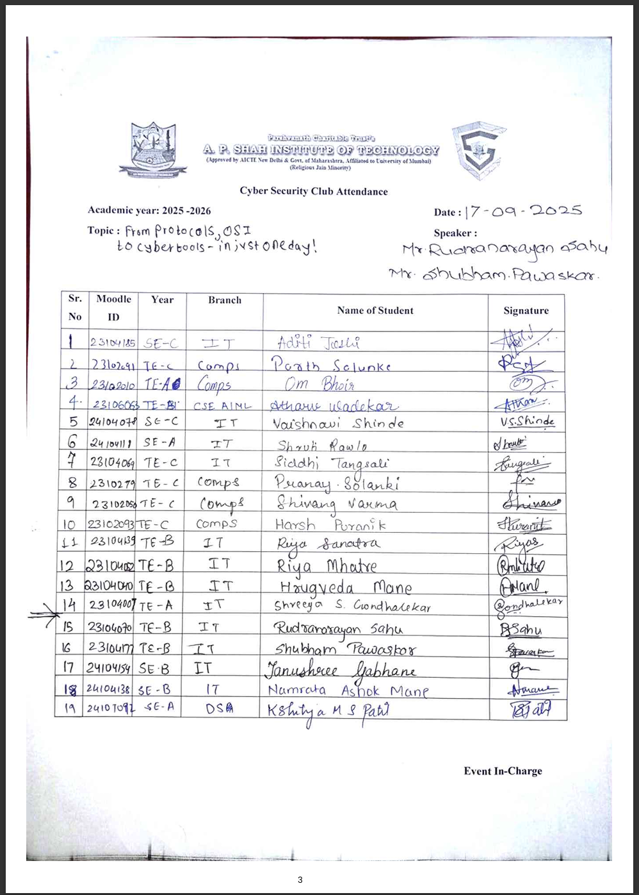


Feedback Form Analysis:

